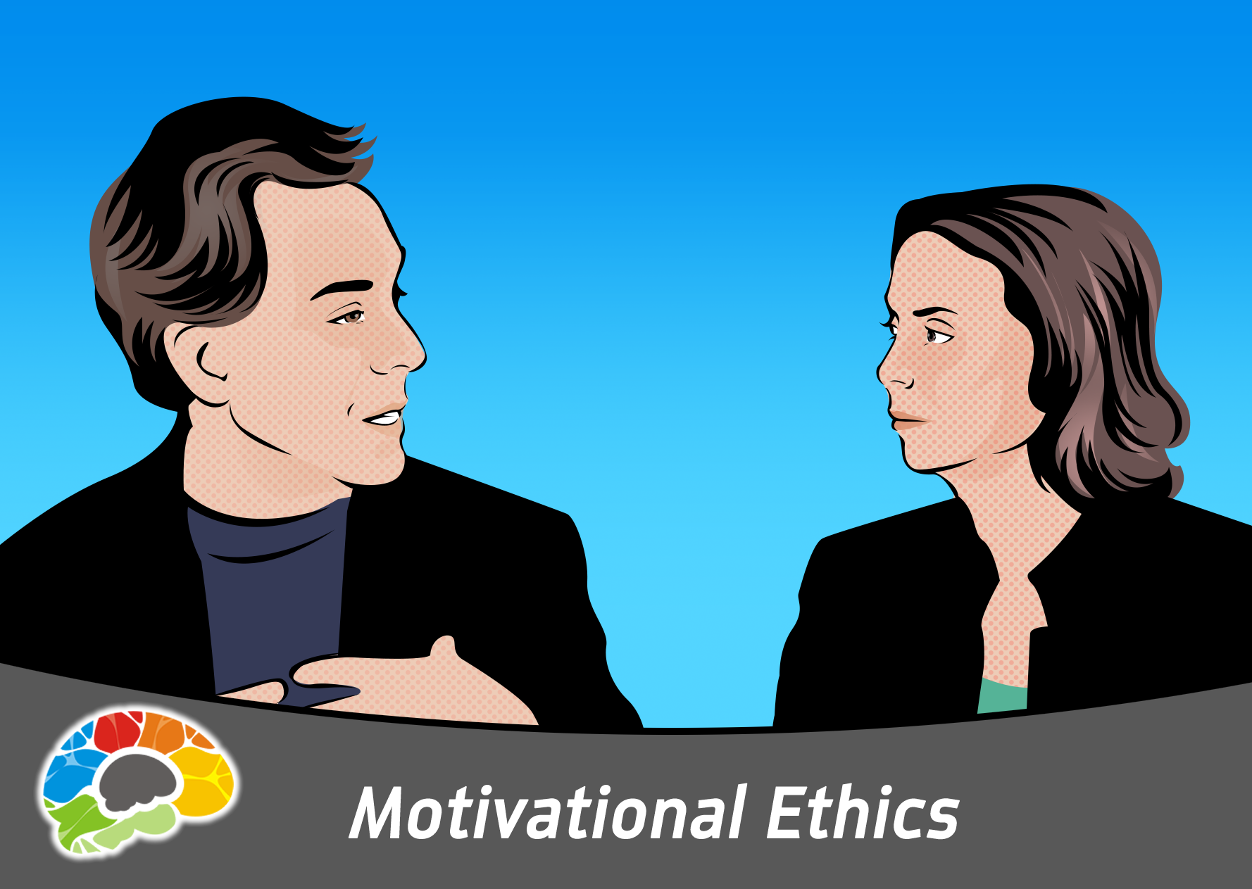

**Modules**: 12

**Seat Time**: 1.75 hours

**Versions Available:** Standard HD SCORM, Vimeo embed

**Teacher**: Chuck Gallagher **Learner**: Kelly Vandever

**Produced by:** Bigger-Brains

# **Title**: Motivational Ethics

## SubHead: **Every Choice Has A Consequence**

## **Objectives. You will be able to:**

* Describe the relationship between bad choices and consequences
* List three legs of the Integral Model
* Discuss the Unethical Continuum

Notes: Searchable.

## Short Description:

**Learn To Avoid Another Being A Failure – And The Critical Keys To Achieving Success**

## Long Description:

**How To Be Successful And Stay Out Of Prison (The “How To” Course On Making Ethical Choices)**

A lot of “good” people find themselves getting fired, or even getting arrested, and have to ask, “How did I end up here?”

You likely didn’t wake up today and make a conscious decision to NOT steal a car or rob a bank. However, you already have made thousands of choices, and those choices will have an inevitable impact on your life, and the lives of others. This course shows how to recognize and understand HOW to be trustworthy, reliable, and honest in your professional and personal life.

**Within The Next Five Years You Could Remain Stagnant, Become Independently Wealthy, Or End Up In Prison**

What determines your future has everything to do with the choices you make. Understanding ethics can do more than help you decipher what is right or wrong. If you understand and apply the laws of ethics, then you can consciously make decisions that will inevitably lead you to become Very Successful.

**This course will show how to:**

* **Make better decisions**
* **Recognize the difference between taking advantage of an opportunity, and making unethical rationalizations**
* **Avoid the “slippery slope” that starts almost innocently, but can ruin your good name**
* **Recognize your motivations, and the connection between need, opportunity, and rationalization**
* **Bring about good consequences from your behaviors and choices**

Ethics are at the core of people and truly successful businesses. Learn to make ethical decisions to navigate your way through choices you make every day.

## Modules Include:

1: Introduction (5:03)

2: Chuck's Story (6:00)

3: The Integral Model (7:56)

4: Bad Choices = Bad Consequences (11:29)

5: The First Leg, "Need" (8:26)

6: The Second Leg, "Opportunity" (6:29)

7: The Third Leg, "Rationalization" (10:30)

8: The Impact of Choices (15:22)

9: The Unethical Continuum (9:15)

10: The Unethical Continuum Continued (7:49)

11: The Human Side of Ethics (4:41)

12: Conclusion (12:23)

## Images:

